The loss of a loved one is life’s most stressful event. When coping with bereavement and grief, people frequently experience a wide range of emotions, even when death may have been expected. There is no real order to the grieving process, and the feelings and emotions that are experienced may range from denial and disbelief to anger, despair, shock and guilt.

These feelings are normal and are common reactions to loss. People are seldom prepared for the intensity and duration of these emotions or how swiftly their moods can change. People often say they feel as if they are ‘losing their mind’, they question their mental stability. These feelings are appropriate and it is common to feel like this. It is part of the grieving process.

Your grief will be expressed physically, emotionally and psychologically. Time is
important, in that you must allow yourself the time to express these emotions. Death is a subject which is frequently avoided, ignored or denied. Sometimes people try to separate themselves from the pain, but grieving cannot be avoided forever.

There are often physical symptoms which
accompany grief; sleep disturbance, loss of weight, loss of energy to name but a few. Existing illnesses may become worse or new conditions or ailments may develop.

Mary was an Oncology Lead Nurse and had to deal with death quite frequently in her job. She knew her patients and their families very

well while under her care and then the patient died…
It seems to be part of the philosophy of our times that our health and well being are our own responsibility. This leads people to believe that everybody should be able to cope with bereavement, ’a stiff upper lip’! This is not always possible, especially when you want to talk about your pain, your grief and the insurmountable sadness which you feel. It is difficult at times to talk to your family or friends, as they have their own pain and grief to deal with. Sometimes you may feel that people don’t want to listen to you, that they have their own lives to get on with; you don’t want to be seen as a burden to others. It also seems at times that you are saying the same thing all the time, talking about your pain and your sadness. This is not unusual and occasionally talking to strangers may help more, especially strangers who understand your loss.

Pat Peake MBE and Mary Casey started this support group in 2000.

Pat had recently lost her husband, who had suffered with cancer, and found that the emotional support which she was offered in the community was ineffectual and did not meet her needs. She felt one-to-one counselling was unhelpful, as the other person (counsellor) had not lost their partner, so how could they hope to know what Pat was feeling? She did look for other help but there was nothing available at the time. Pat had also had cancer at the same time as her

husband, and felt a sense of guilt that she was the survivor. He was her soul mate and to this day she still misses him every day.

There was no follow up and, after the death certificate was given to the family, they were left to try to and get on with their lives. This seemed to Mary to ‘leave an unfinished chapter’. How could the caring and support for the family stop because the loved one had died?

This is why and how the idea of ’Healing Hearts’ was conceived.
Death is a fact of life and without
death there is no life.

Pat
In 2012, Pat was presented with the honour of
an MBE at Buckingham Palace for her service
to the community through this group.

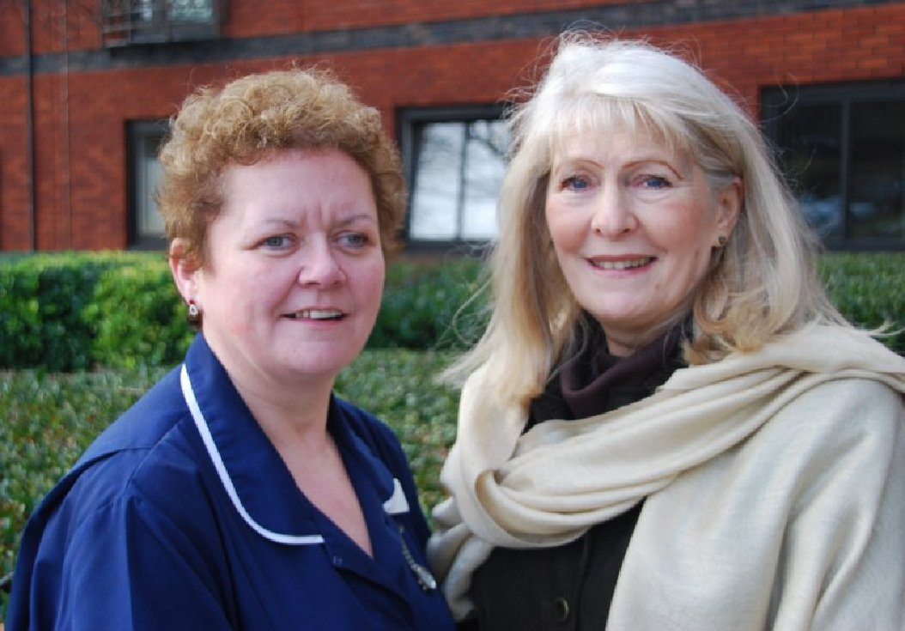

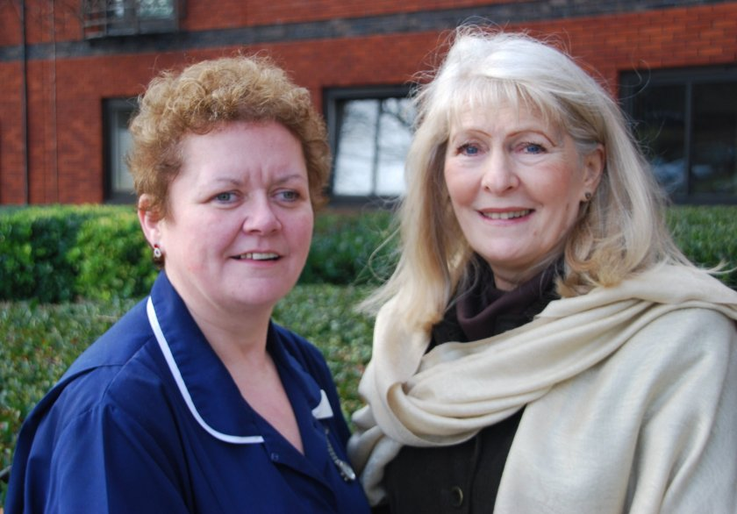
Mary and Pat

OUR AIM

The aim of the group is to enable successful grieving to occur. The group is informal and is run on a voluntary basis. There is no charge to belong to the group or attend the meetings. We offer support to everyone who attends and we are there to help people to cope with what is happening to them at the time. The members of the group have all suffered the death of a loved one and are fully aware of what bereavement brings. The group offers help and assistance to each other and people are encouraged to exchange telephone numbers if they wish, so that they can contact each other between meetings if they want to.

The meetings are held every 4 to 5 weeks at The Hainault Forest
Community Association
100b Manford Way
Chigwell, Essex. IG7 4DF

They start at 7pm

We ask that a donation of £1 be made
at the end of each meeting to help
cover costs of the meeting room

Many people attend the group for a while and then leave with an open invitation to return, if they want to, at any time. Support groups, however, are not for everyone; it is an individual choice and one that each person must make for themselves.

Death is an important part of life. It is a painful experience but something which no one can avoid. Although grief is always the penalty for loving someone, it can give us the opportunity to move on with greater insight and understanding once grief has started to resolve.

FOR FURTHER DETAILS
PLEASE CONTACT

PAT PEAKE MBE - Tel: 0208 500 4838
MARY CASEY - Tel: 07710 155360

or view our web site at:-

WWW.HEALINGHEARTS.UK

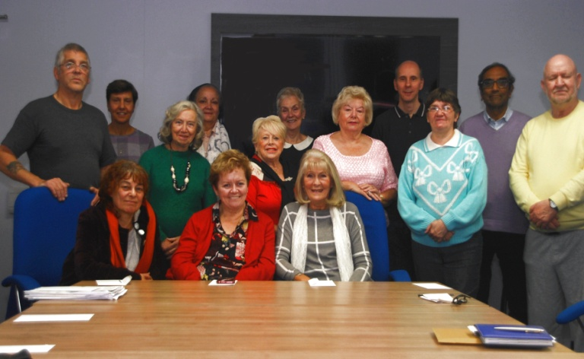

HEALING HEARTS

BEREAVEMENT

SUPPORT GROUP

